

**APPLIED PHYSICS LAB**

**Lab Report: Finding Resistance by Color Coding Method**

**Submitted To:**

Sir. Haseen Ullah Jan

**Submitted By:**

Ali Asghar

Section C

Registration No. 21PWCSE2059

Department Of Computer Systems Engineering

Fall 2021

**COLOR CODING:**

Resistor values are often indicated with color codes. Practically all leaded resistors with a power rating up to one watt are marked with color bands. The coding is defined in the international standard IEC 60062. This standard describes the marking codes for resistors and capacitors. In addition to defining the color bands, the standard also includes numerical codes, as often used for surface mount SMD resistors.

The color code is given by several bands. Together they specify the resistance value, the tolerance, and sometimes the reliability or failure rate. The number of bands varies from three to six. At a minimum, two bands indicate the resistance value and one band serves as multiplier. The resistance values are standardized; these values are called preferred values.

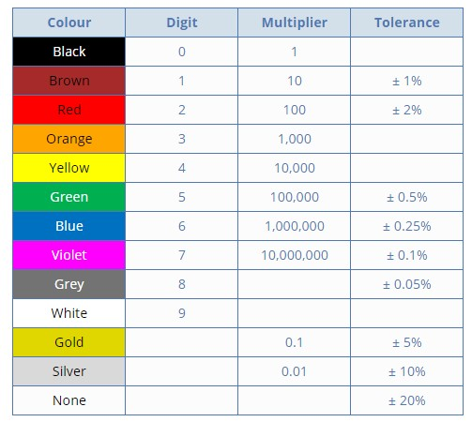

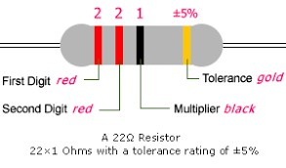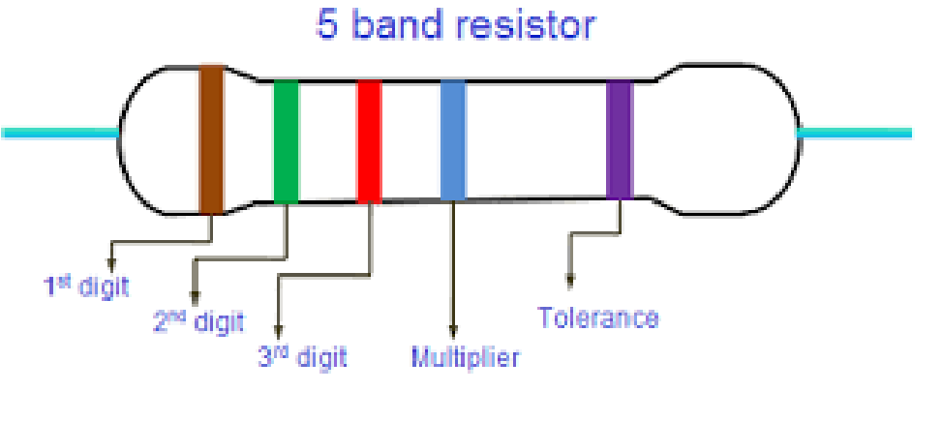

**APPARATUS:**

1. Different resistors with color bands.
2. Multimeter.

**PROCEDURE:**

The resistance of a given resistor can be found by following method:

1. First band give me tens number in numerical value of the resistance.
2. Second band give me unit number in numerical value of resistance.
3. Third band gives the value of in numerical multiple of ten for the first value.
4. Fourth band gives the resistance tolerance.

**READINGS:**

|  |  |  |  |  |  |  |  |
| --- | --- | --- | --- | --- | --- | --- | --- |
| S. No. | 1st Band | 2nd Band | 3rd Band | 4th Band | Resistance in  Ohms Ω | Readings of Ohm meter | Error |
| 1 | 4 | 3 | 102 | ±5% | 43x 102 ±5% | 4.25K Ω | 0 |
| 2 | 1 | 0 | 105 | ±5% | 1x 105 ±5% | 0.956M Ω | 0 |
| 3 | 1 | 0 | 107 | ±5% | 1x 107 ±5% | 9.62M Ω | 0 |
| 4 | 1 | 5 | 103 | ±5% | 15x 103 ±5% | 14.3x 103Ω | 0 |
| 5 | 2 | 2 | 101 | ±5% | 22x 101 ±5% | 21.7x 101 Ω | 0 |
| 6 | 4 | 7 | 103 | ±5% | 47x 103 ±5% | 0.7 Ω | 0.206 |
| 7 | 6 | 8 | 10−1 | ±5% | 68x 10−1 ±5% | 6.9 Ω | 0 |